12.Design DFA using simulator to accept the input string “a” ,”ac”,and ”bac”.

AIM:TO write DFA using simulator to accept the input string “a” ,”ac”,and ”bac”.

DIAGRAM:

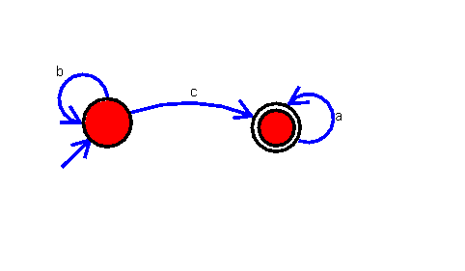

INPUT:

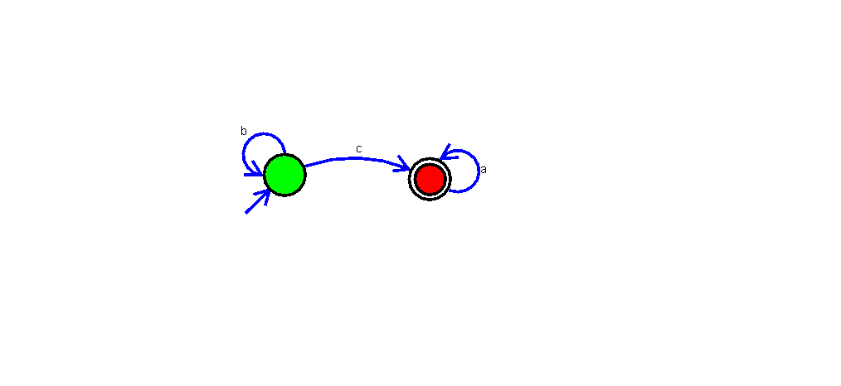 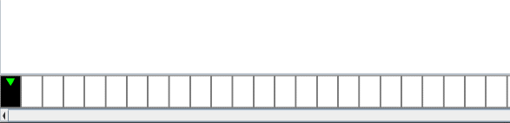

U

OUTPUT:

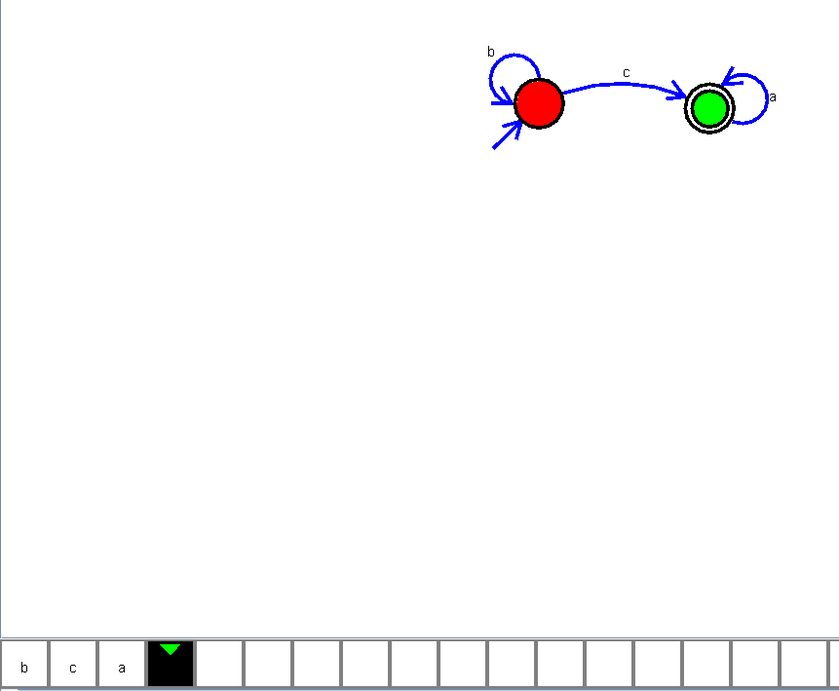

RESULT:

The implementation of DFA using simulator to accept the input string “a” ,”ac”,and ”bac” is successfully completed.